FINANCIAL CHATBOT

Name: Veera Venkata Saravana Kumar Pasala

Levels Completed: Dynamic Instruction Manual for adaptive responses.

**Objective:**

In this project we need to develop Chatbot using ML/LLM algorithms and then evaluate its performance. ML is the normal algorithms and LLM are the large language models which can be used to train Chatbot. Here we are utilizing CNN based algorithm to train questions given by you for financial data. In below screen showing questions and answers given by you for Chatbot.

**Approaches:**

Utilize both ML and LLM algorithms for Chatbot training, leveraging their respective strengths in processing natural language.

Employ a CNN-based algorithm specifically tailored for training the Chatbot on financial data-related questions and answers.

Evaluate the Chatbot's performance by monitoring training and validation loss metrics, aiming for lower values indicating better understanding and response generation.

Develop the project using Flask, a Python web framework, with distinct modules for training ML algorithms and enabling user interaction with Chatbot.

**Challenges:**

Selecting the appropriate ML/LLM algorithm involves navigating through various options, each with its own complexities in natural language understanding.

Ensuring satisfactory training performance requires addressing challenges related to convergence and effectiveness, particularly when dealing with large datasets and complex language models.

Integrating ML/LLM algorithms into Flask necessitates careful design and implementation to ensure seamless functionality and user experience.

Handling user input effectively poses challenges, including accommodating diverse language patterns and specialized financial terminology to provide accurate responses.

**Functionality Demonstration:**

I will demonstrate the training process and performance visualization of the ML algorithm.

Following the training demonstration, I will interact with the Chatbot by inputting various text queries and receiving real-time responses.

**Users input text queries in this module:**

So, we are using above questions and answers to train Chatbot using CNN algorithm and we are evaluating CNN performance in terms of training and validation loss. The more loss the decrease the better is the algorithm.

To implement this project, we have designed two modules using FLASK framework.

Train ML Algorithm: using this module user can train ML algorithm can visualize algorithm training performance as evaluation.

Interact with Chatbot: here user will enter some text and then Chatbot will predict answer for user text and display output as response.

**Training ML Algorithm Module:**

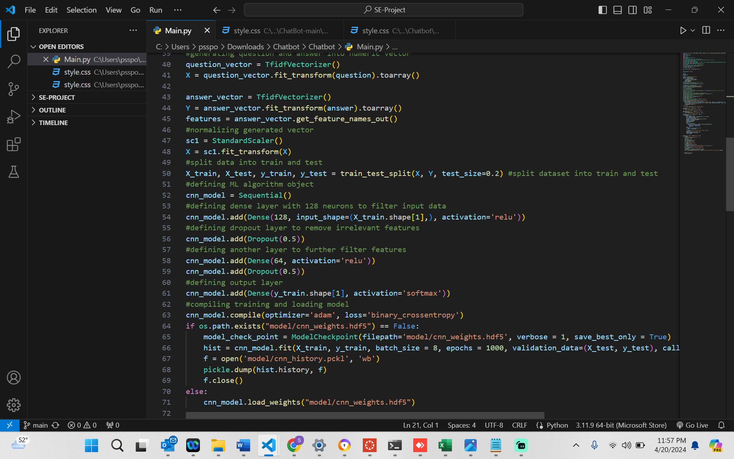

In above screen defining ML algorithm to train Chatbot with given question and answers.

To run project, install python 3.7.2 and then install all packages given in requirements.txt file and then double ‘run.bat’ file to start FLASK server and get below page

**Flask Implementation:**

In above screen FLASK server started and now open browser and enter URL as <http://127.0.0.1:5000/index> and press enter key to get below page

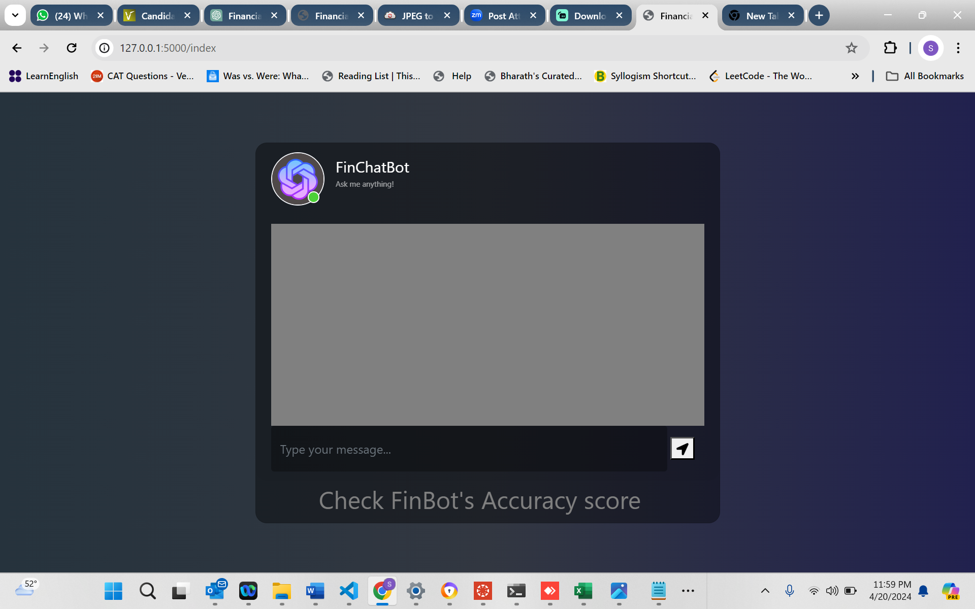

In above screen user can click on ‘Train Chatbot ML Algorithm’ link to get below output

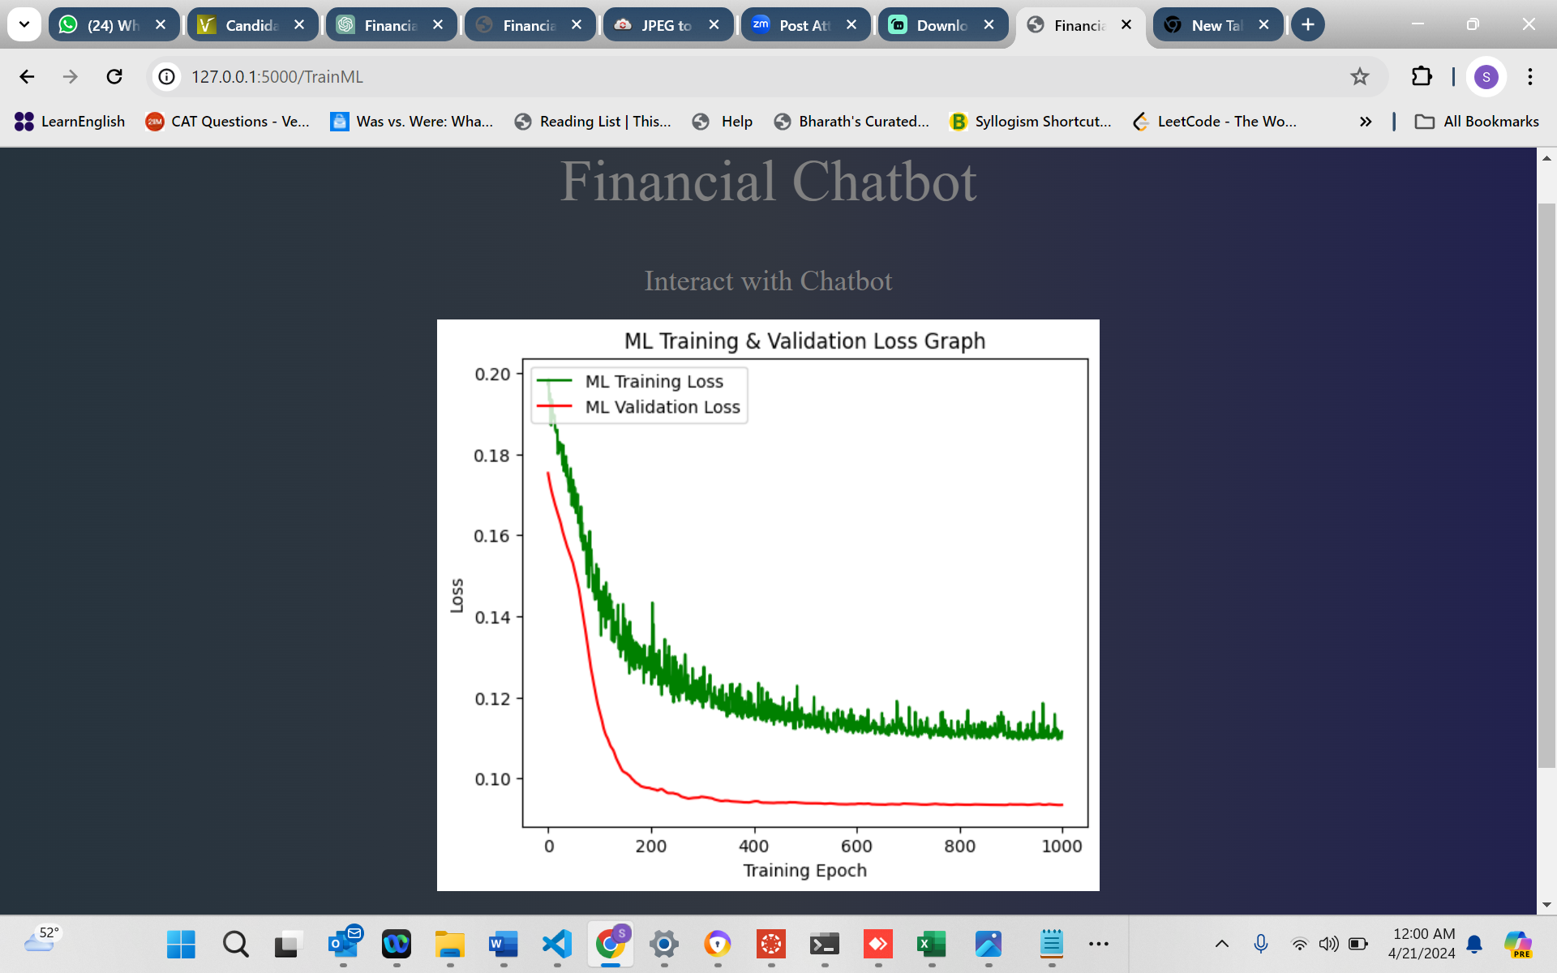

In above graph x-axis represents training epochs and y-axis represents LOSS values and can see with each increasing training epoch loss values get decrease for both training and validation. Green line represents validation loss and red line represents training loss. In above graph loss started from 0.20 and reached closer to 0. Now click on ‘Interact with Chatbot’ link to get below page.

In above screen in text field, you enter question from your financial file or Dataset.csv file and then press button to get below response from Chatbot.

**User Experience:**

In above screen can see response from Chatbot for all those questions given in Dataset file.

**REFLECTIONS:**

Through this exercise, I've gained valuable insights and learnings:

**Algorithm Selection:** Understanding the significance of choosing the right ML algorithm for Chatbot training. Experimentation and evaluation help in determining the most effective approach.

**Model Evaluation**: Learning to assess model performance using metrics like training and validation loss. This aids in understanding the effectiveness of the trained model and areas for improvement.

**Flask Integration:** Gaining experience in integrating ML models with web frameworks like Flask. This involves designing user-friendly interfaces and ensuring smooth communication between frontend and backend components.

**User Input Handling:** Recognizing the challenges of handling diverse user inputs. Effective preprocessing and text processing techniques are vital for accurate Chatbot responses.

**Real-world Applications**: Exploring practical applications of Chatbots, particularly in industries like finance. Understanding how Chatbots can streamline processes, provide insights, and enhance user experiences.

**Continuous Improvement**: Embracing a mindset of continuous improvement by iterating on models, incorporating user feedback, and refining algorithms over time.